# Smart Student Enrollment and learning Portal (Phase 5)

**Goal:**

The goal of this project is to build a Salesforce-based Student Enrollment and Learning Portal that automates the complete admission process. It will streamline student inquiries, course enrollments, and fee tracking while reducing manual effort and delays. Automated notifications and reminders will improve communication with students and faculty. Overall, the system will enhance efficiency, accuracy, and reporting, ensuring a smoother enrollment experience for educational institutes.

**Problem Statement:**

Educational institutes face challenges in managing student inquiries, admissions, and course enrollments due to manual processes. This causes delays, missed follow-ups, and inefficiency. A Salesforce-based portal will automate lead capture, admissions, fee tracking, and notifications, ensuring faster enrollment and better reporting.

# Phase 5: Apex Programming (Developer)

Phase 5 focuses on **Apex Programming** to enhance system functionality through custom logic. In this phase, custom **Apex Triggers, Classes, and SOQL queries** were developed to automate business processes and provide advanced functionalities for the Smart Student Enrollment and Learning Portal.

## ****Apex Trigger****

* Developed an Apex Trigger to automatically generate an **Enrollment record** whenever a new **Student** is added to a **Course**.
* This ensures enrollments are consistently created without requiring manual intervention.

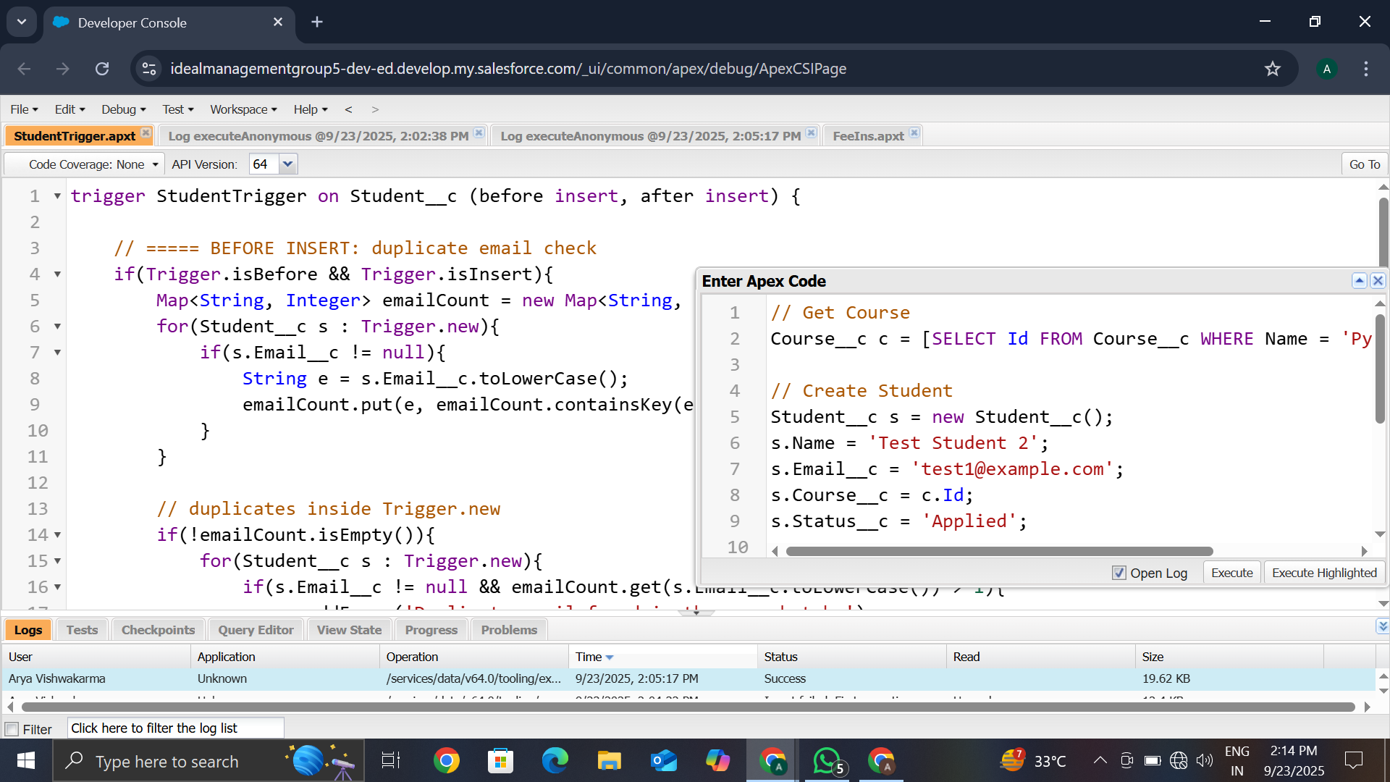

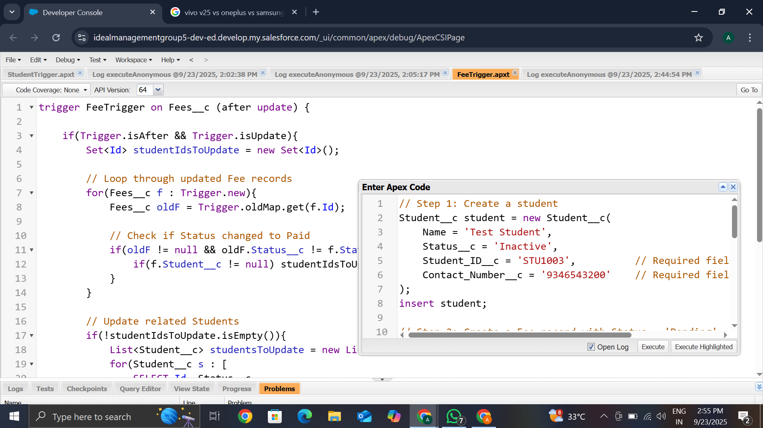

## ****SOQL Queries****

* Designed SOQL queries to fetch **student-course enrollment reports**.
* Generated **fee collection summaries** per batch and course.

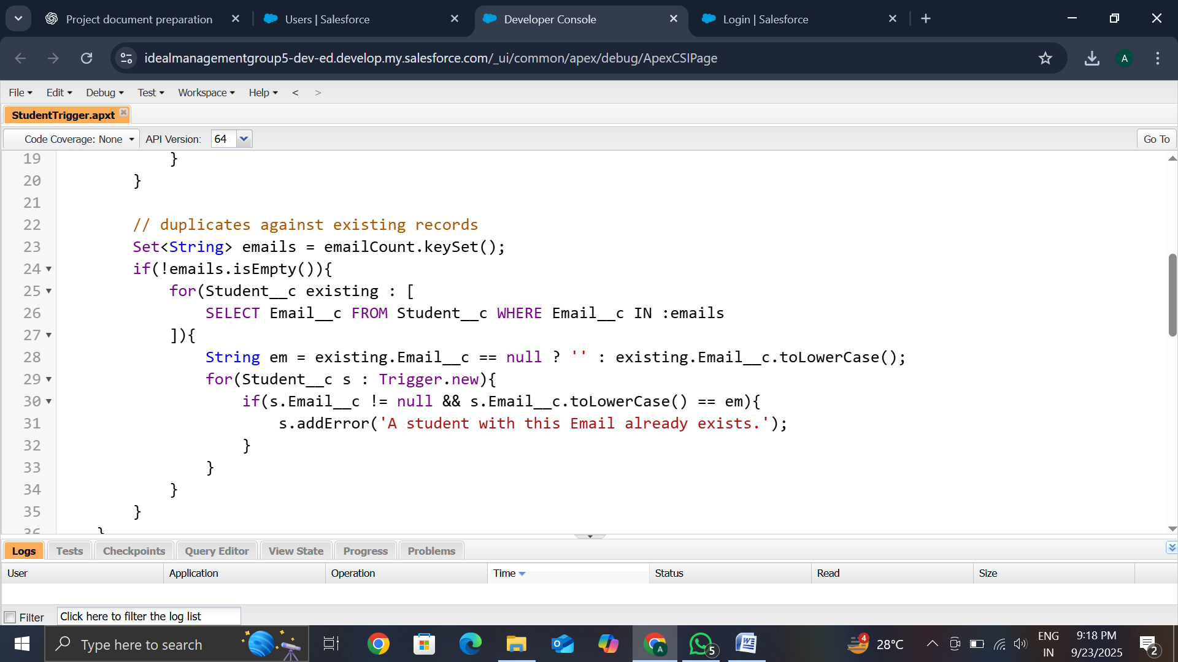

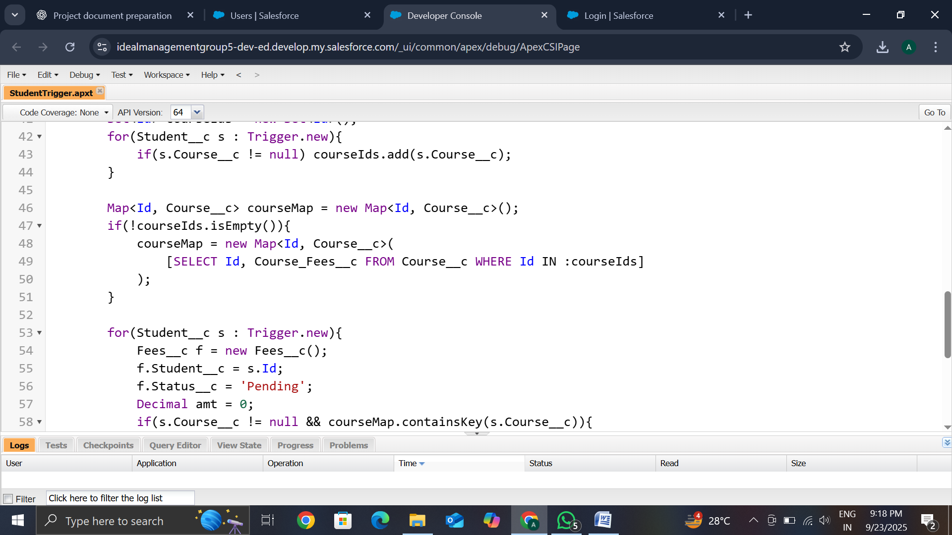

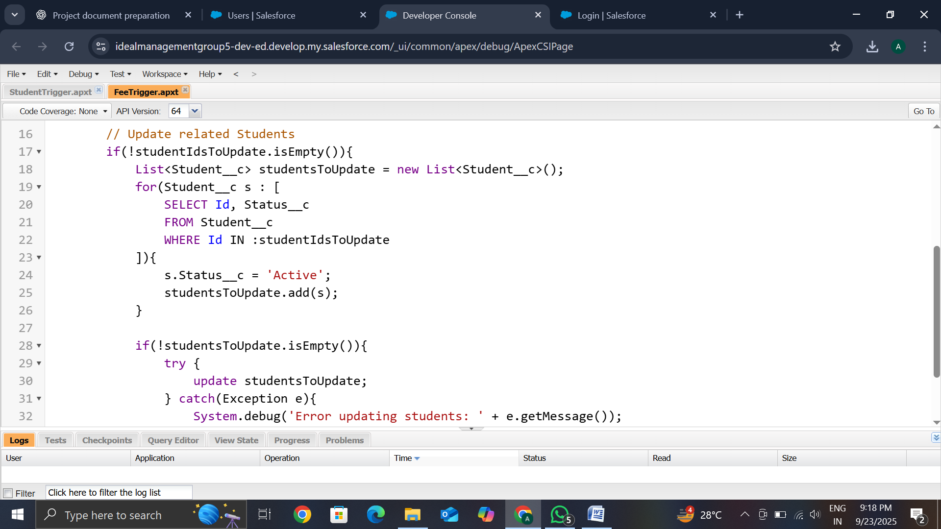

## ****Test Classes****

* Added Test Classes to validate Apex logic and ensure **code coverage**.
* Improved reliability and enabled successful deployments.
* Maintained compliance with Salesforce **best practices**.

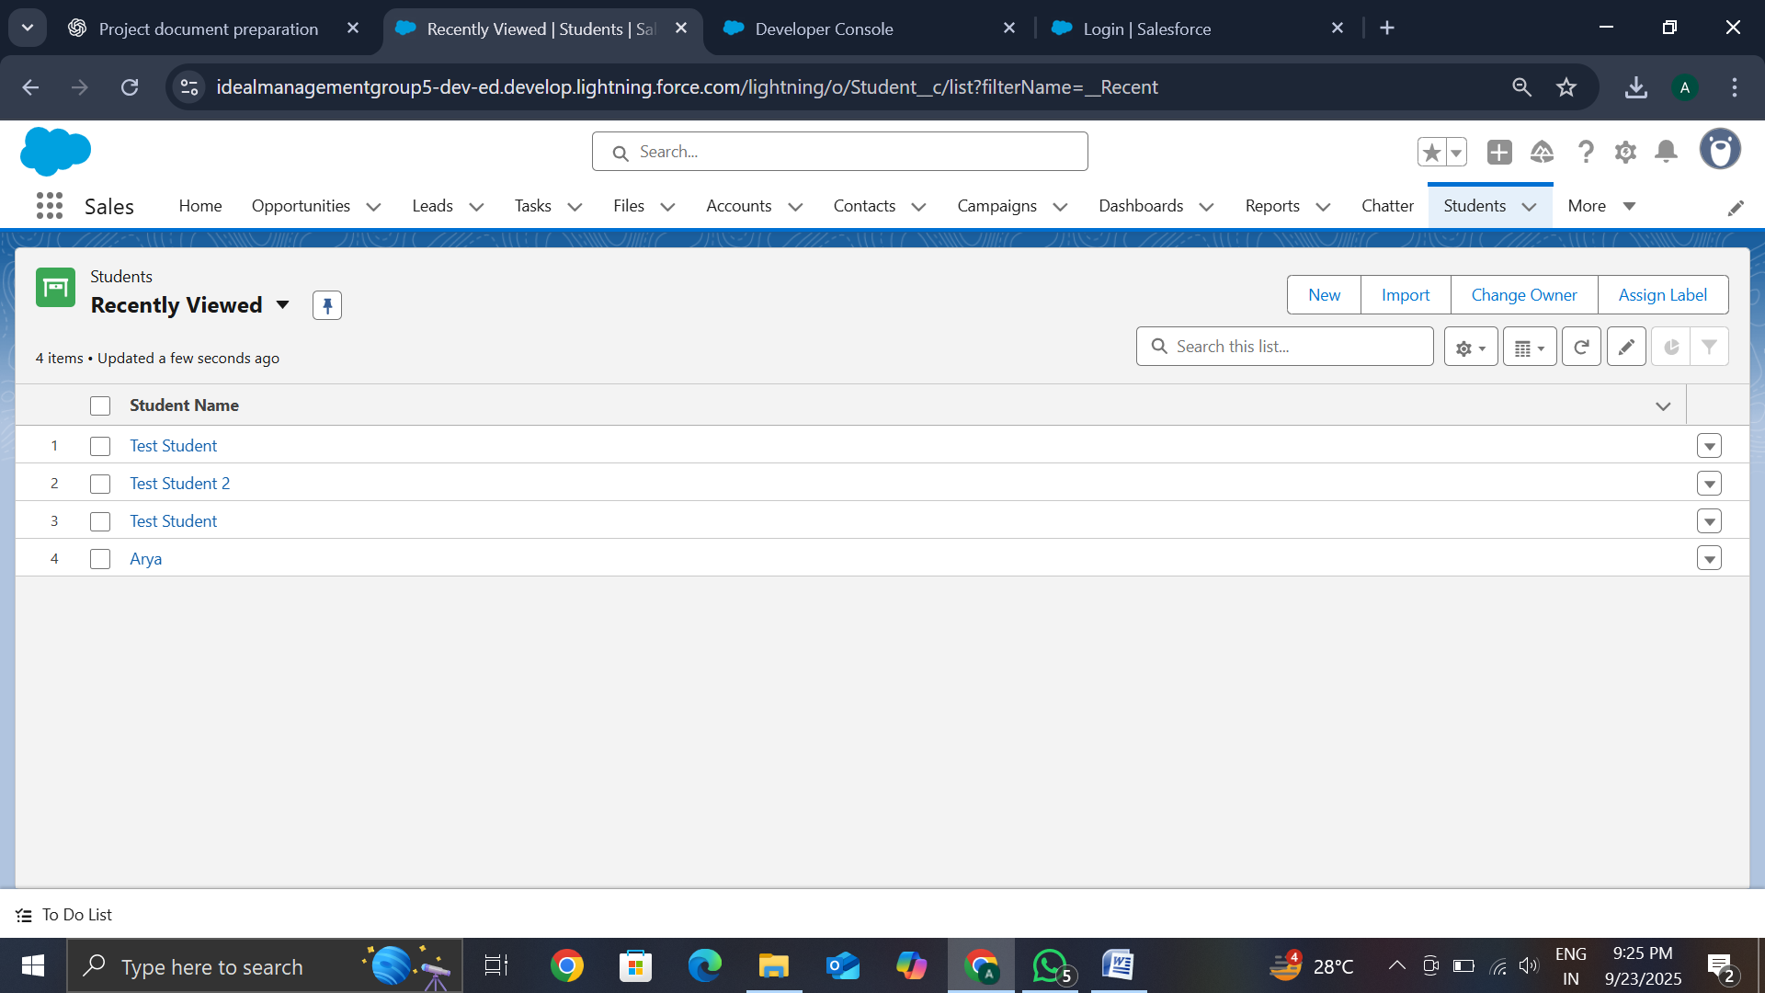

Made Using Apex Triggers Automatically (Test Student)

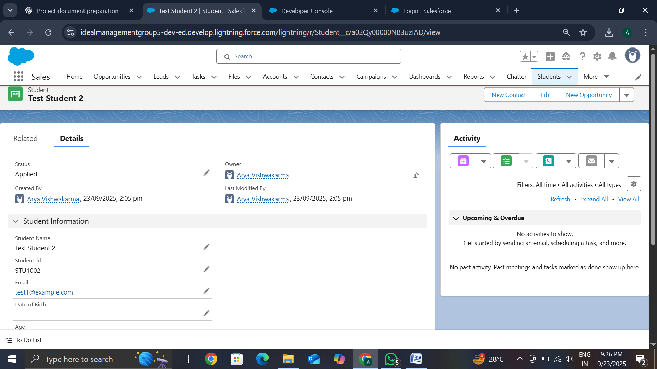

APPLIED

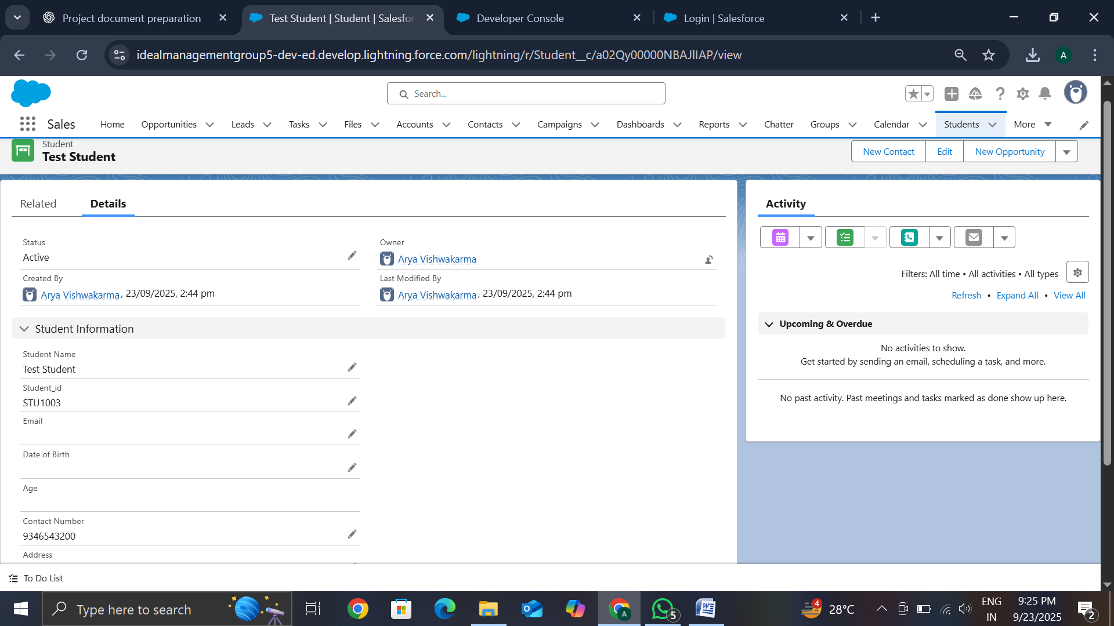

ACTIVE

## ****Conclusion****

Phase 5 successfully introduced **Apex Programming** into the project. By implementing triggers, classes, and SOQL queries, along with robust test coverage, the system achieved advanced automation and custom logic. This ensured **accurate fee calculations, streamlined enrollments, and comprehensive reporting**, strengthening the portal’s functionality.